**注册流程**

**Registration Process**

1. 点击注册链接：<http://epay.dhu.edu.cn/p>

Click the link: <http://epay.dhu.edu.cn/p>

1. 初次登录请先注册，点击右上角注册按钮

Please register the system first, click the “register” in the upper right corner.

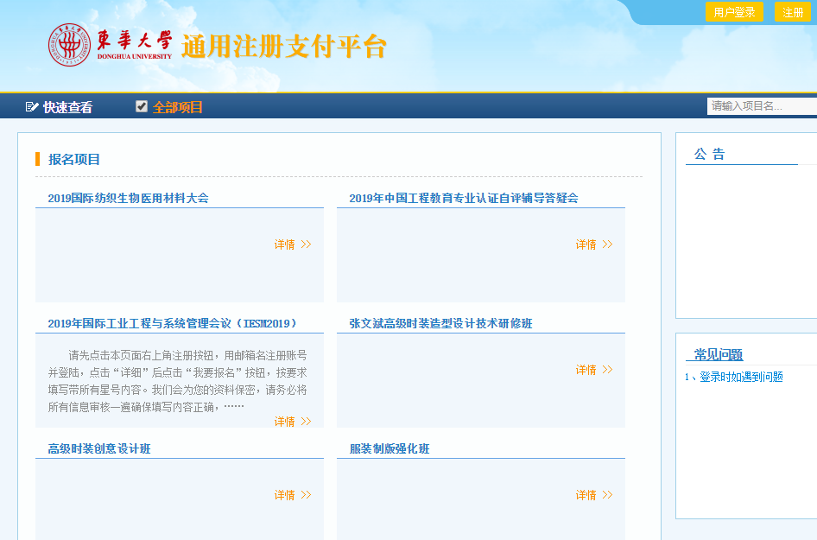

1. 输入个人信息

Input your personal information

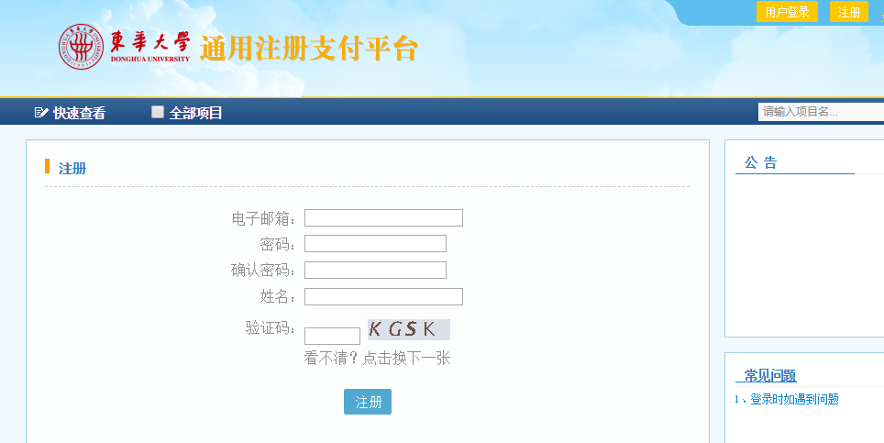

1. 注册成功后，即可登录

Click “Login” when you finish the registration.

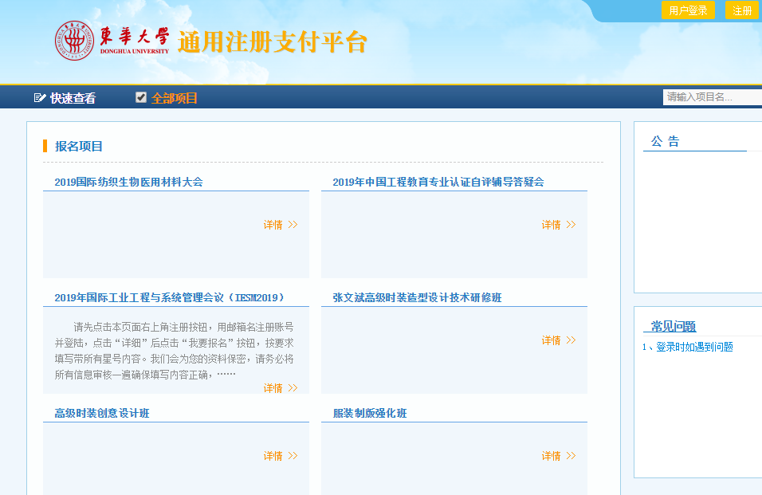

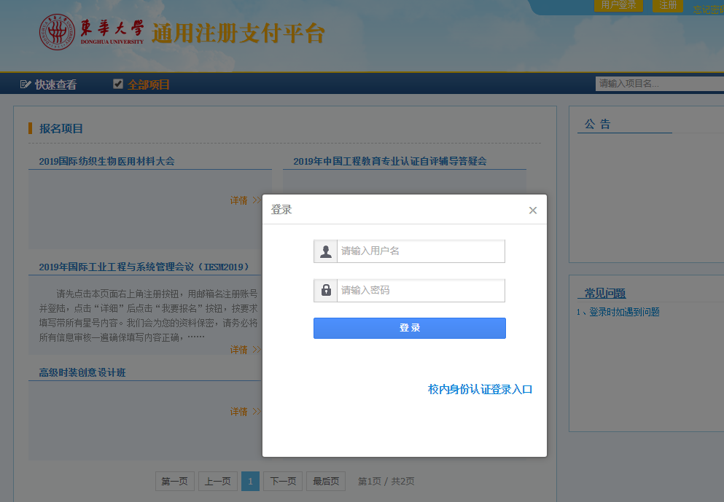

1. 点击“2019国际纺织生物医用材料大会”

Click “MedTex 19 & IFBMTM 2019”

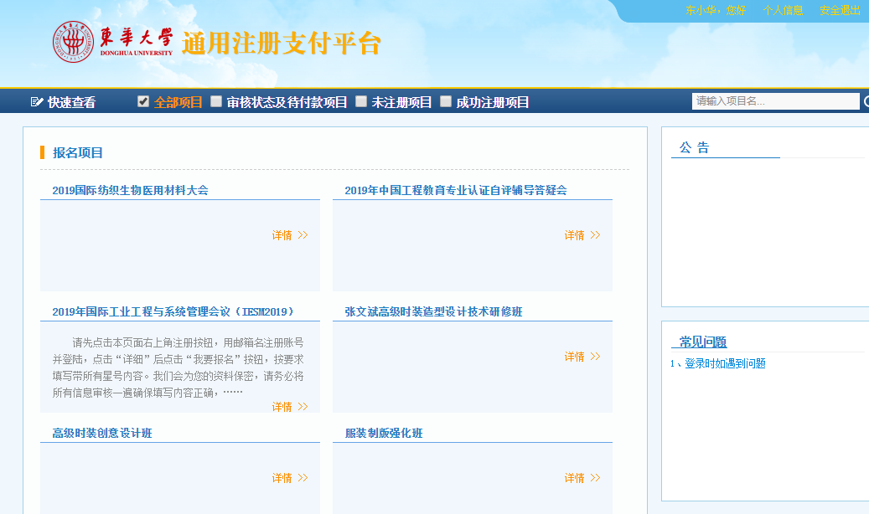

1. 点击我要报名，即注册此次大会

Click “Register” for registration of this conference

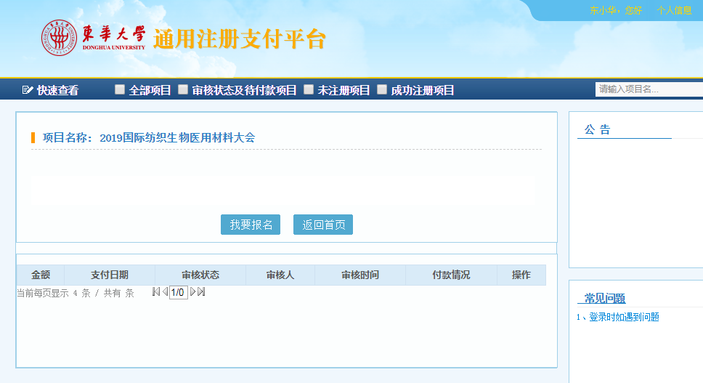

1. 输入相关信息，点击保存

Input your information, and click “Save”

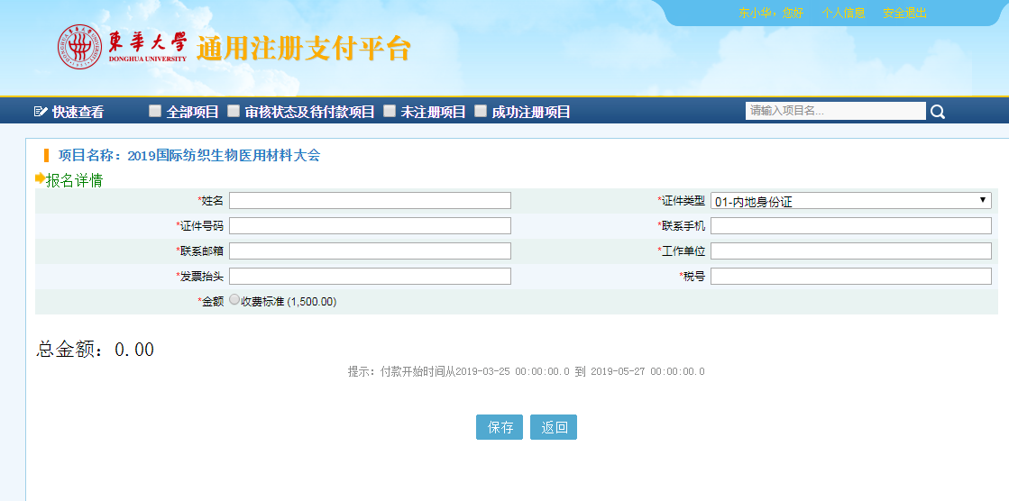

1. 点击付款按钮

Click “Pay”

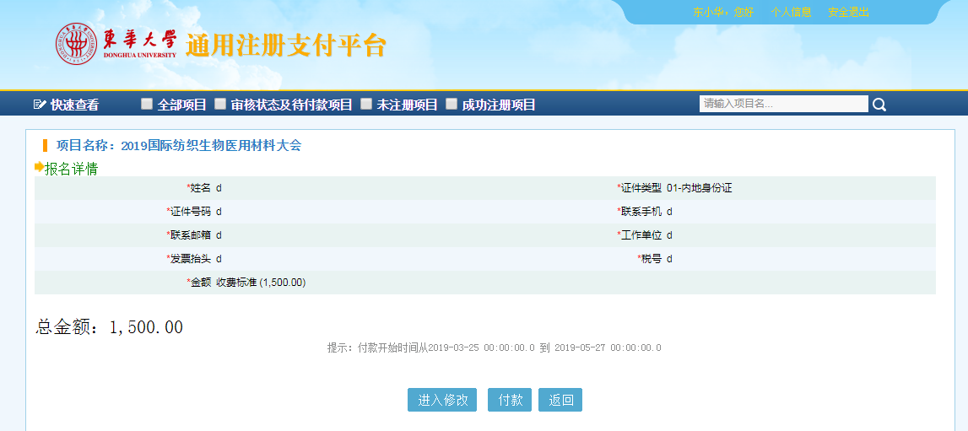

1. 若为外币卡，请点击“这里”

Please click the button below if you pay with foreign currency.

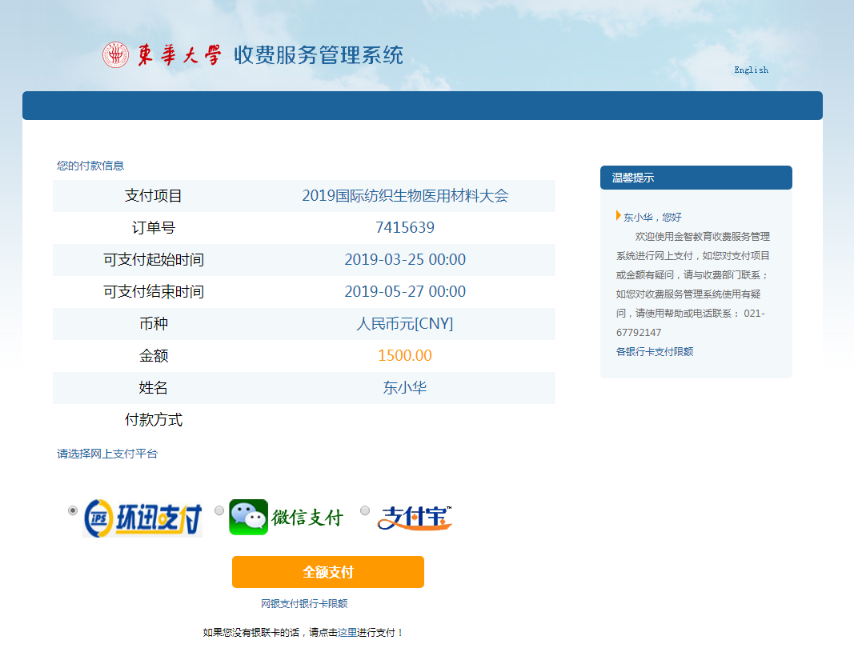

这将产生额外的手续费，点击确定按钮

This will cause extra processing fee (46.50 RMB), click “Yes”

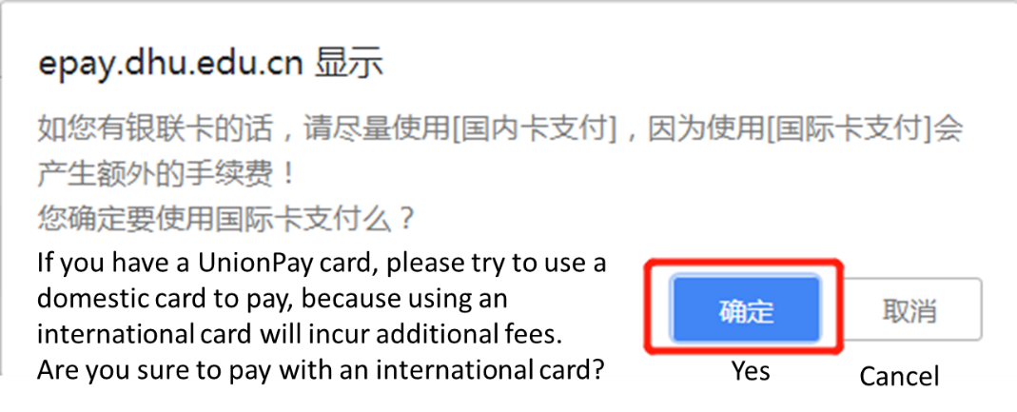

手续费为46.50元人民币，点击确定按钮

The processing fee is 46.50 RMB, click “Yes”

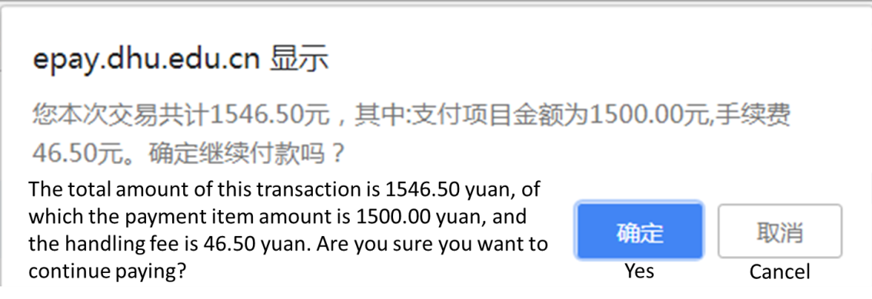

1. 按照指示完成付款

Pay according to the instruction

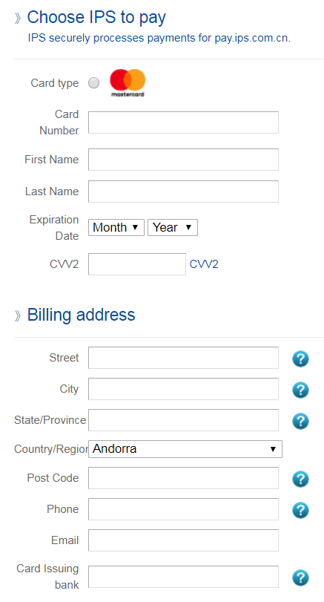

1. 注册和付款完成

Registration and payment completed.